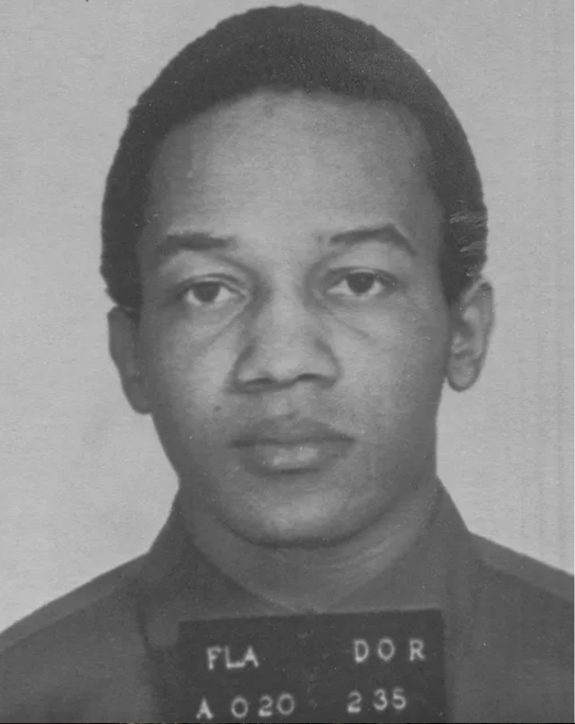
Strickland vs Washington (1984)
No. 82-1554
Argued January 10, 1984
Decided May 14, 1984
466 U.S. 668

Timeline:
- September 20, 1976: David Washington and an accomplice commit a series of crimes, including the murders of Daniel Pridgen and Katrina Birk, and the abduction and assault of Frank Meli.
- September 27, 1976:Washington and his accomplice abduct and hold Frank Meli captive for two days.
- September 29, 1976: Washington kills Frank Meli.
- Plea and Sentencing: Washington pleads guilty to murder in Florida state court. At sentencing, his attorney does not present mitigating evidence (such as character witnesses or a psychiatric evaluation), and Washington is sentenced to death.
- State Court Appeals: Washington appeals his sentence in state court, alleging ineffective assistance of counsel, but the state courts deny his claims.
- Habeas Corpus Petition: Washington seeks habeas corpus relief in federal court, arguing that his Sixth Amendment right to counsel was violated by his attorney's ineffective performance at sentencing.
- Federal Court of Appeals: The U.S. The Court of Appeals for the Fifth Circuit reversed the lower court's decision, finding that Washington's counsel was ineffective.
- U.S. Supreme Court: The Supreme Court grants certiorari to review the case, consolidating it with a similar case from the Eleventh Circuit.
- January 10, 1984: Oral arguments are held before the Supreme Court.
- May 14, 1984: The Supreme Court issues its decision in Strickland v. Washington, establishing ineffective assistance of counsel claims.
- July 13, 1984: Washington is executed.

What Happened?
In 1976, David Washington and two accomplices went on a crime spree where, over several days in September, they committed burglary, kidnapping, and three murders. He was sentenced to death after pleading guilty to multiple murders. He later argued that his attorney's performance in court was ineffective, specifically during the sentencing phase, because the attorney did not investigate or present mitigating evidence that would shed a positive light on Washington’s character.
The trial judge sentenced Washington to death on each of the murder counts. The Florida Supreme Court affirmed Washington's sentences on direct appeal. Washington then filed a habeas corpus petition in federal district court alleging, inter alia, ineffective assistance of counsel based on the same errors asserted in the state court. After an evidentiary hearing at which the trial judge testified, the district court concluded that "there does not appear to be a likelihood, or even a significant possibility" that any errors made by trial counsel had prejudiced the outcome at sentencing.
What Did the Supreme Court Decide?
.
Washington then sought collateral relief in state court, alleging, inter alia, ineffective assistance at the sentencing proceeding. The trial court denied relief based on the record evidence. They found that "the record affirmatively demonstrates beyond any doubt that even if [counsel] had done each of the... things [that respondent alleged counsel had failed to do at the time of sentencing, there is not even the remotest chance that the outcome would have been any different. The plain fact is that the aggravating circumstances proved in this case were completely overwhelming..." The Florida Supreme Court affirmed Washington's sentences on direct appeal, holding that:
[A] confession plus numerous aggravating factors limit the alternatives of the most zealous of advocates...counsel's failure to investigate medical reports and cross-examine the medical examiners could not be prejudicial since the facts of the reports were admitted by the defendant in his confession. Under the circumstances, cross-examination could have accomplished little. Indeed, cross-examination is a trial tactic choice properly within counsel's discretion.
The United States Court of Appeals for the Fifth Circuit said: "The district court employed an incorrect method of analysis". By holding that Washington had failed to show prejudice, "the district court was, apparently, borrowing from the analysis employed in Knight and DeCoster, which require that a petitioner carry the burden" of showing prejudice. They also said "the court erred in attaching any probative value whatsoever to Judge Fuller's testimony" about whether the errors asserted by Washington would have made a difference at sentencing. After the Fifth Circuit Court of Appeals Reorganization Act of 1980 divided the Fifth Circuit, the newly created United States Court of Appeals for the Eleventh Circuit decided to rehear the case en banc and reversed the Fifth Circuit's ruling, stating that the Sixth Amendment accorded criminal defendants a right to "reasonably effective" counsel. After outlining standards for judging whether defense counsel fulfilled the duty to investigate nonstatutory mitigating circumstances and whether counsel's errors were sufficiently prejudicial to justify reversal, it remanded the case for application of the standards.
The State of Florida appealed the decision to the United States Supreme Court, which granted certiorari. The Court, in a decision by Justice O'Connor, established a two-part test for an ineffective assistance of counsel claim:
- Counsel's performance "fell below an objective standard of reasonableness"
- Counsel's "deficient performance prejudiced the defense"
The Supreme Court began its decision with the idea that the Sixth Amendment right to counsel "plays a crucial role in the adversarial system embodied in the Sixth Amendment". The Strickland standard is based on the Sixth Amendment's purpose to protect the right to a fair trial guaranteed by the Due Process Clause:

Why is this Significant and Important?

This Supreme Court case established the standard for determining when a criminal defendant's Sixth Amendment right to effective assistance of counsel has been violated. The Court established a two-part test to assess such claims, requiring defendants to prove both deficient performance by their attorney and prejudice resulting from that deficiency.

The Two-Pronged Test:
To prove ineffective assistance of counsel, a defendant must show:

Deficient Performance: Counsel's representation fell below an objective standard of reasonableness, meaning their performance was not reasonably effective.

Prejudice: This deficient performance prejudiced the defense, meaning there is a reasonable probability that the outcome of the proceeding would have been different had counsel's performance been effective.

