Missouri v. Frye (2012)

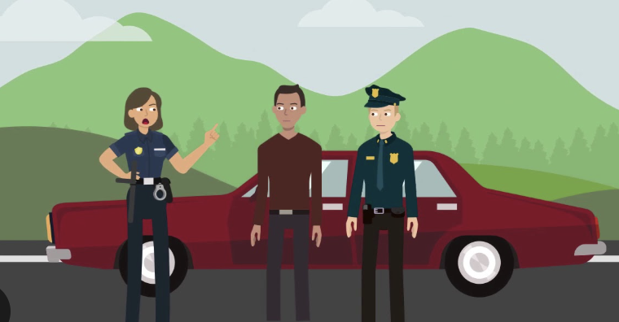
Docket No. 10-444
Granted: January 7, 2011
Argued: October 31, 2011
Decided: March 21, 2012

What happened?
Galen Frye was arrested in Missouri for driving with a revoked license. He had done this before, so this time it was a felony (a serious crime). Being that it was his 3rd offense, he was slated for a maximum 4 year prison sentence.
The prosecutor (the lawyer against Frye) offered a plea deal: Frye could plead guilty and get 90 days in jail instead of a longer sentence. He essentially had the option of immediately pleading guilty to lower the severity of his sentence and his felony would become a misdemeanor.
But Frye’s public defender (his lawyer) never told him about the deal. Because his defender failed to tell him about the reduced plea deal, the deal expired and he was never notified of the reduced deal.
Before the court date, Frye was arrested again for driving without a license. At this point he had no alternate options and pleaded guilty to the charges. However, after discovering what his alternate option was, he filed a petition to the court. His original motion to the court was denied but the Missouri appellate court reversed it, citing the Strickland case that he wasn’t effectively given his options when they were present.
Frye later said: “If I had known about that deal, I would’ve taken it.” Which makes sense as a 90 day misdemeanor sentence was much better than serving a 4 year felony charge.

What did the Supreme Court decide?
In 2012, the U.S. The Supreme Court ruled in Frye’s favor 5-4. The Majority opinion cited the Padillo v. Kentucky case as one of the precedents. Similar to the case, the defendants argued their guilty plea was invalid because they were not given proper advice on their plea deals.

Majority Opinion (Most Justices Agreed):
Frye’s right to a fair trial was broken because his lawyer was deemed ineffective (they failed to provide specific details on his plea deal)
Frye also would’ve likely taken the reduced plea deal, meaning his inability to receive information of this deal stripped him of an effective and fair trial.
Main Point: If a lawyer doesn’t tell their client about a plea deal, that client may be denied a fair trial.
This opinion was written by Justice Anthony Kennedy.

Dissenting Opinion (Some Justices Disagreed):
The dissenting opinion focused on two main things, one being the speculative aspect of making a ruling that he would’ve taken a plea deal, and that his counsel’s error didn’t deny him of any procedural rights. While yes his counsel made an error, it wasn’t denied nor were any procedural issues made. They also didn’t feel that they should be labeling a plea deal invalid because another plea deal wasn’t taken. In their eyes, the plea deal that Frye wasn’t notified of was considered a plea deal that wasn’t taken. Even if he was notified of it, they can’t say he would’ve just pled guilty to the reduced plea deal.
Main Point: They thought the Constitution should not be used to review plea deals that were never accepted or a speculated acceptance of a plea deal.

Why is this significant and important?
This case helps protect people by making sure:
- Lawyers share all offers from prosecutors.
- Defendants understand their options before deciding.
It supports fair treatment in the legal system, especially for people who may not know all their rights.

Before you find out… stop and think!

What is the key question you think the Supreme Court will be answering?
________________________________________________________________________________________________________________________________________________________
____________________________________________________________________________

Explain how a judge may disagree with Frye’s argument? (Keep in mind two courts prior to the S.C. had different opinions!)
____________________________________________________________________________
____________________________________________________________________________
____________________________________________________________________________

Why might a judge side with Frye? (Keep in mind two courts prior to the S.C. had different opinions!)
____________________________________________________________________________
____________________________________________________________________________
____________________________________________________________________________

Predict what the Supreme Court ruled, knowing only the background information. Give a short explanation as to what ruling(s) would be made. (If unanimous give one opinion, if not give a majority and dissenting/minority opinion)

____________________________________________________________________________
____________________________________________________________________________
____________________________________________________________________________

