**The Racial Divide in the United States in 1967: A Vote for the Future of The Movement**

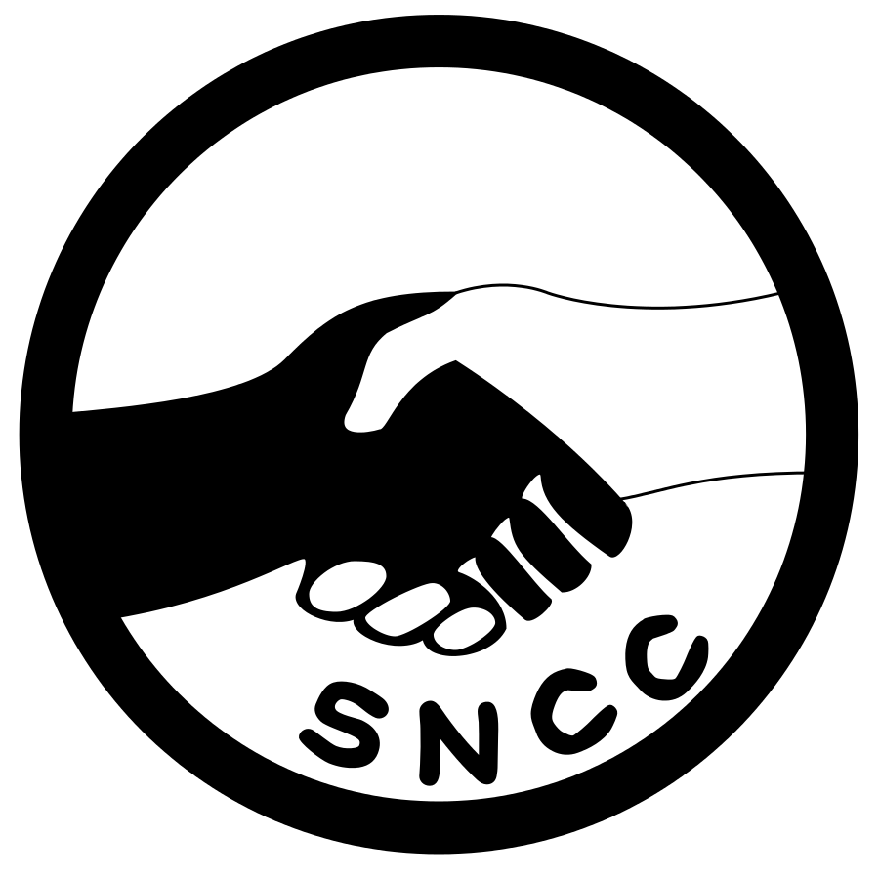

**Historical Context**

In 1967, the United States was deeply divided along racial lines, a schism rooted in centuries of systemic racism and segregation. Despite the passage of landmark legislation in the early 1960s, such as the Civil Rights Act of 1964 and the Voting Rights Act of 1965, which aimed to dismantle institutionalized discrimination, the struggle for true equality was far from over.

**Social and Economic Inequities**

African Americans continued to face profound disparities in housing, employment, education, and law enforcement. Urban areas, particularly in the North, were rife with tension as many African Americans found themselves trapped in ghettos with limited economic opportunities. The frustration over these persistent inequalities boiled over into violence, culminating in significant civil disturbances. The Detroit (Could use Watts too) riot of July 1967, one of the most devastating of the era, highlighted the depth of racial animosity and the urgent need for change.

**Political Inequities**

Despite the Voting Rights Act of 1965, many African Americans still faced barriers to political participation. Voter suppression tactics, such as literacy tests, poll taxes, and intimidation, were used to disenfranchise Black voters, particularly in the South. Furthermore, the lack of African American representation in political offices meant that Black communities had little influence over the policies that affected their lives. This political marginalization compounded the social and economic inequalities, perpetuating a cycle of disenfranchisement and disadvantage.

**Shifting Strategies in Civil Rights Movements**

By 1967, there was a noticeable shift in the strategies and philosophies of major Civil Rights groups. Initially, the movement had been largely characterized by nonviolent protest and integrationist goals, epitomized by leaders such as Dr. Martin Luther King Jr. and organizations like the Southern Christian Leadership Conference (SCLC).

**Martin Luther King Jr. and Nonviolent Resistance**

Dr. Martin Luther King Jr. remained a staunch advocate for nonviolent resistance and continued to push for racial integration and economic justice. In 1967, King expanded his focus to include economic inequality and the Vietnam War, criticizing the government's priorities and advocating for a broader social revolution. His "Poor People's Campaign" aimed to unite poor people of all races in a fight for economic justice.

**Rise of Black Power and Militancy**

Simultaneously, there was a growing faction within the Civil Rights Movement that began to question the efficacy of nonviolent protest. This faction was embodied by the rise of the Black Power movement, led by figures such as Stokely Carmichael (later known as Kwame Ture) and organizations like the Student Nonviolent Coordinating Committee (SNCC) and the Black Panther Party.

* **Stokely Carmichael and SNCC**: Carmichael, who had become disillusioned with nonviolent tactics and the slow pace of change, advocated for Black Power—a philosophy that emphasized racial pride, economic empowerment, and the creation of political and social institutions for Black people. In 1967, Carmichael's message resonated with many African Americans who were frustrated with the slow progress of the Civil Rights Movement.
* **Black Panther Party**: Founded in 1966 by Huey P. Newton and Bobby Seale, the Black Panther Party took a more militant approach, advocating for self-defense against police brutality and establishing community programs to address issues such as poverty and health care. By 1967, the Panthers had become a symbol of Black resistance and empowerment, garnering significant attention and support.

**A Pivotal Vote for SNCC**

As we approach 1968, the Student Nonviolent Coordinating Committee stands at a critical juncture. The question before us is clear: What should our agenda be moving forward?

* **Inclusion vs. Exclusion:** Should we continue advocating for racial integration and cooperation with white allies, aligning with Dr. King and the SCLC’s vision of a multiracial democracy? Or should we shift toward Black self-determination, limiting white involvement and focusing on strengthening Black communities independently?
* **Nonviolent Resistance vs. Self-Defense/Violent Tactics:** Do we remain committed to strict nonviolent resistance as our primary strategy, even in the face of violence and oppression? Or should we assert our right to self-defense, potentially embracing more militant tactics to protect our people and our cause?
* **Political vs. Economic Focus:** Is securing voting rights, political representation, and legislative change our top priority? Or should we focus more on economic empowerment—combating poverty, unemployment, and systemic barriers to Black wealth?

**Conclusion**

The decision we make will shape the future of our movement and our fight for justice. As we prepare to vote, let us consider the lessons of 1967, the challenges we face, and the aspirations of our community. Our path forward must reflect our commitment to equality, justice, and empowerment for all African Americans.