BD Newscast Perspective Doc Social

Social Impact of The Black Death

The Black Death, ravaging Europe in the 14th century, had significant social impacts on society. Some of the unique social issues that were brought forward by the Black Death are things such as demographic devastation, labor shortages, disruptions of the feudal system, social mobility, and the rise of the middle class, as well as social reforms such as sanitation and quarantines regulations to try to prevent the spread of the disease any further. The rise of racism and prejudice were at an all-time high facing one group, the Jews, and setting a precedent for the first small-time holocaust the world had ever seen. Overall, the Black Death had far-reaching social consequences. It disrupted demographic patterns, transformed economic structures, challenged established hierarchies, and sparked religious and cultural changes that shaped Europe for centuries.

Document 1: Walter S. Zaptoczny Social Consequences of the Black Death 1348-1351

“The Black Death caused extreme racial attacks on Jewish people due to the fact many people felt as if the church protected them.”

The Black Death had many long-term consequences. One was a series of attacks on Jews,
lepers, and outsiders who were accused of poisoning the water or the air. Lepers were
singled out and persecuted. Anyone with a skin disease such as acne or a rash was thought to be a
leper with leprosy (highly contagious skin disease). Leprosy was believed to be an outward sign of a sinful life. Lepers were murdered throughout Europe.

The attacks against Jews began in the south of France but were most dramatic in parts of Switzerland and German areas with a long history of attacks on local Jewish communities. Massacres in Bern, Switzerland were typical of this pattern; after weeks of fearful tension, Jews were rounded up and burned or drowned in marshes. Sometimes there were attacks on Jews even where there was no plague. This persecution was often done, not solely out of religious hatred, but as a way of attacking the Kings or the Church normally protecting the Jews. Jews were often called the King's property and it was a way for people to lash out at the institutions (church and political leaders) that they believed had failed them. Fewer Jews died from the Black Death, in part due to their religious laws which called for a lifestyle that was, in general, cleaner than that of a Christian medieval villager. Also, Jewish ghettos (segregated neighborhood) kept them more separate from the general population. This made Jews seem suspicious. The Pope, the leader of the Catholic Church, and most public officials condemned the
murders and tried to stop them. In the face of mob fury, however, they were often unsuccessful.
Renewed religious fervor and fanaticism bloomed in the wake of the fear caused by the Black Death. Fierce pogroms against the Jews by townspeople (massacres of helpless people) frequently resulted in the death or banishment of most of the Jews in a town or city. By 1351, 60 major and 150 smaller Jewish communities had been exterminated, and more than 350 separate massacres had occurred.

Document 2: The Psyche of Hysteria
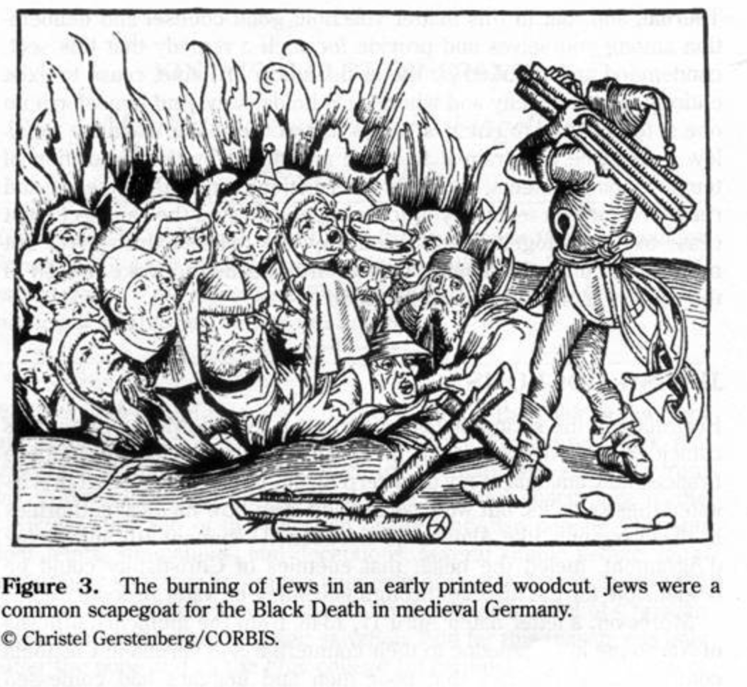

Document 3:
Excerpt from The Black Death
The Great Mortality of 1348-1350 written by John Aberth

Description of changes to public gatherings due to the Black Death.

Funerals:
It had once been customary, as it is again nowadays, for the women relatives and neighbors of a dead man to assemble in his house in order to mourn in the company of the women who had been closest to him; moreover, his family would gather in front of his house along with his neighbors and various other citizens. High ranking people would have several priests attend their funeral, while less important people had one or two. The body would be taken to the church where the person wanted to be buried. The body was carried on the shoulders of his peers through the streets in a funeral parade with people holding candles to pay respects. But as the number of deaths increased from the plague, funerals began to disappear entirely and were replaced by different customs. Not only did people die without having many women around them, but a great number departed this life without anyone at all to witness their going... Moreover, it was rare for the bodies of the dead to be accompanied by more than ten or twelve neighbors to the church, nor were they borne on the shoulders of worthy and honest citizens, but by a kind of gravedigging fraternity, newly come into being and drawn from the lower income groups of society. These people created a new occupation called a sexton and demanded a flat fee for their services, which consisted in taking up the coffin and hauling it swiftly away, not to the church specified by the dead man in his will, but usually to the nearest at hand. Sextons would be preceded by a group of four or six clerics, who between them carried one or two candles at most, and sometimes none. Nor did the priests go to the trouble of pronouncing solemn and lengthy funeral rites, but with the aid of these so-called sextons, they hastily lowered the body into the nearest empty grave they could find.
Weddings:
Family festivities and weddings had no more place [in life]. No one issued an invitation to a feast during the whole time of the epidemic, and one did not hear any concerts.

