Speakers | Viewpoint
School Officials Favoring Integration  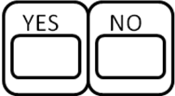 | 1.  2.  3.
School Officials Opposing Integration | 1.  2.  3.
Black Parents Favoring Integration | 1.  2.  3.
White Parents Opposing Integration | 1.  2.  3.
Black Activists Favoring Integration | 1.  2.  3.
Black Activists Opposing Integration | 1.  2.  3.
Additional Notes:

