**School Board Meeting: White Parents Opposing Integration**

**1. *Debating the Civil Rights Movement, 1945-1968* p. 60**

“…a former President of the United States, unanimously declared in 1927 in *Lum v. Rice* that the “separate but equal” principle is “…within the discretion of the State in regulating its public schools and does not conflict with the Fourteenth Amendment.” This interpretation, restated time and again, became a part of the life of the people of many states and confirmed their habits, customs, traditions and way of life. It is founded on elemental humanity and common sense, for parents should not be deprived by government of the right to direct the lives and education of their own children.”

*Q. Who should have the decision of where students go to school?*

*Q. What way of life is this person referring to?*

**2. Clarence Morrison, general contractor in Shelby, NC *There Goes My Everything* p. 58-59**

“The relations[s] between the races are the worst in my community than I have known in my lifetime.” To many white southerners, the age of civil rights marked the nadir (lowest point) of race relations. They had considered black workers close friends for many years. When civil rights struggles exposed black discontent, whites despaired that the days of “good race relations” were gone.

*Q. Why do you think Mr. Morrison feels that his relationships with blacks have changed?*

**3. Tom Tarrants, 17 years old; *Oh, Freedom!* p. 116**

“I didn’t start off against anyone, but during the civil rights movement in the South, they began integrating the public schools in Alabama, where I was raised. Everything was in turmoil because a whole way of life was being overturned.”

*Q. What was Tom’s way of life?*

*Q. Why was his way of life in turmoil?*

**4. Editorial: *Birmingham News*, May 18, 1954**

“Admittedly segregation has produced emotional reactions that have not always been good…but we are much concerned that the ending of segregation may produce feelings and problems far more difficult to deal with.”

*Q. What problems are going to be “more difficult to deal with?”*

**5. Excerpts from U. S. Federal District Judge Lemley’s decision on request for a two and one-half year delay of integration, June 20, 1958**

. . . [W]hile you can disperse crowds and can keep the Negro students physically within the school, and while it is possible that, if the troops were deployed in sufficient numbers all over the school, vandalism could be checked, the presence of troops cannot reduce or eliminate racial tensions or create a climate that is conducive to education.

*Q. Why is the presence of military personnel not going to eliminate racial tensions?*

**6. Picketers in Poolesville, Maryland**

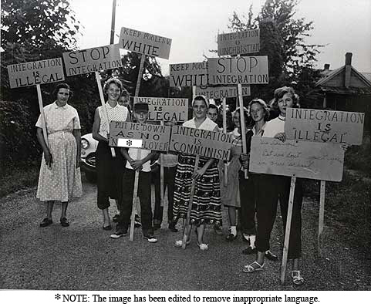

*Q. The 10th amendment to the U.S. Constitution says, “The powers not delegated to the United States by the Constitution, nor prohibited by it to the States, are reserved to the States respectively, or to the people.” How would these people holding the signs use the 10th amendment to support hteir claim that integration is sillegal?*

**7.** In November 1960, six-year-old Ruby Bridges Hall became the first African American child to desegregate an elementary school. Although she only lived a few blocks from the William Frantz Elementary school in New Orleans, Louisiana. Marshals had to escort Ruby because of angry segregationist mobs that gathered in front of the school. For an entire year, she was the only student in her class since white parents pulled their children from the school in protest.

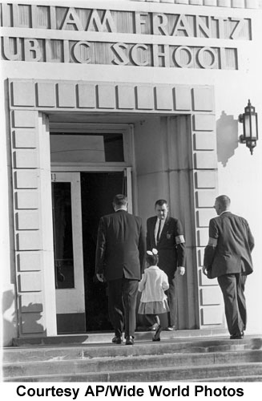

*Q. How would this image represent unsuccessful school integration?*

# 8. *Integration Has Failed, Part II Separation is everywhere — because all races want it.*

“There is nothing wrong with segregation. Most African Americans with good sense want the same social relations that most whites want. We don’t want them living in our neighborhoods. We don’t want our children going to school with theirs. We don’t want our daughters and sons marrying their sons and daughters. No thanks … we don’t want or need social integration. We want economic and political integration …

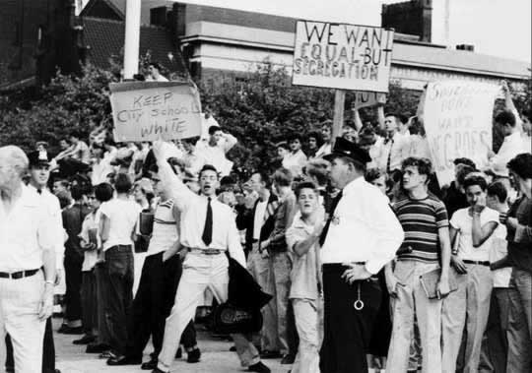

*Q. What would be the difference between “Equal but Segregation” and integration?*

**9. White men painting signs asking other whites to keep their kids at home.**

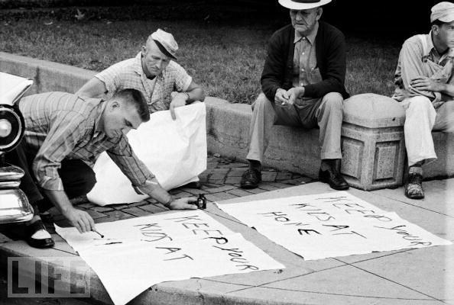

*Q. Why are these men asking for other whites to keep their kids at home?*