**The Sedition Act is like a Boa Constrictor Having a Meal......**

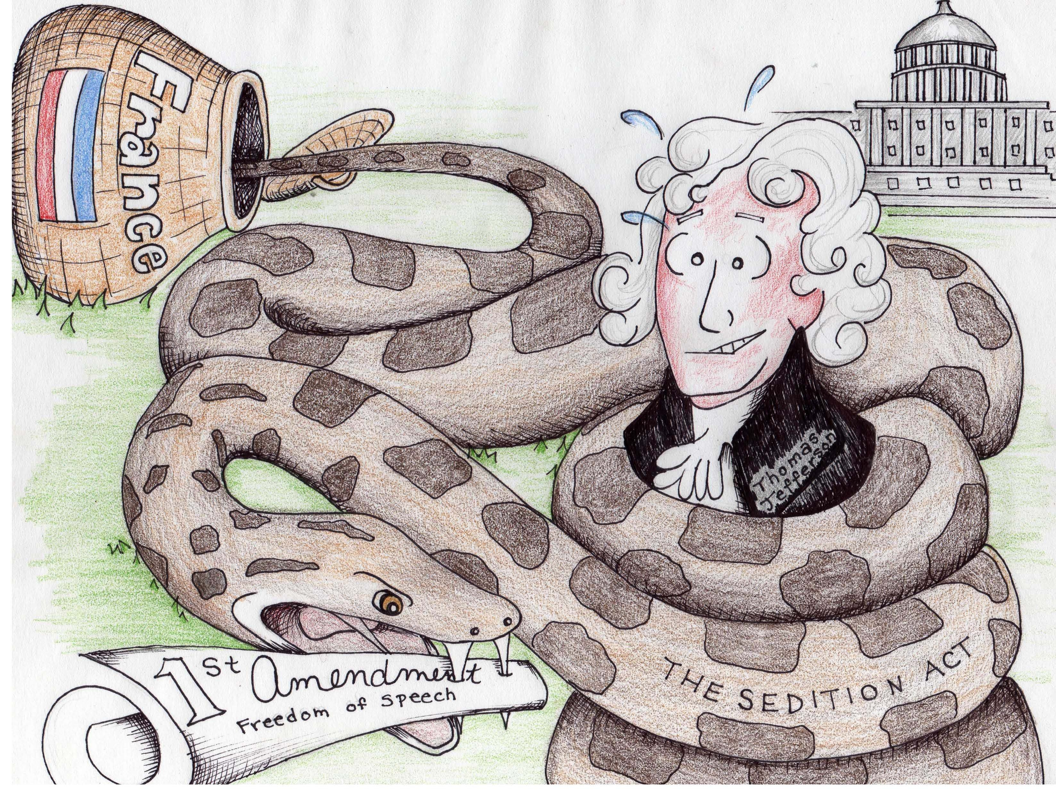

**Because....**

* the boa constrictor emerges from hiding to blindside its prey just as Sedition Act emerged suddenly out of an irrational fear of French-style revolution.
* the boa constrictor squeezes its prey before eating it just as the Sedition Act was a political ploy determined to “squeeze” the Republicans (Jefferson) of all ability to resist the Federalist majority (the Capitol building).
* the boa constrictor violently swallows its prey just as the Sedition Act violently destroyed the protections of the First Amendment to the Constitution.

**Differences:**

* The image implies that the Sedition Act came from France which is not true. The Federalist majority in the U.S. Congress passed the bill and it was signed by a Federalist president, John Adams. The Federalists argued, however, that, if the Sedition Act was not passed, French-inspired pressmen would brainwash Americans into violently and unjustly revolting against their government.
* The Federalists argued that the Sedition Act was a war time measure necessitated by the quasi-war with France. At the time the Sedition Act was passed, the French and American naval fleets were actively engaged in conflict. In addition, French agents were believed to be in the American frontier promoting sedition. The metaphor largely ignores the argument that the Sedition Act was needed to protect American national security.