**School Board Meeting: School Officials Opposing Integration**

**Examples of unsuccessful desegregation attempts**

**1. Little Rock Integration Timeline: Central High School of Little Rock, Arkansas**

**May 17, 1954** Supreme Court in Brown v. Board of Education of Topeka, Kansas rules that segregated schools are unconstitutional.

**May 24, 1955** The School Board votes unanimously to adopt Superintendent Virgil Blossom's plan of gradual integration that would start in September, 1957, at the high school level and add the lower grades over the next six years. Mr. Blossom is named "**Man of the Year**" by the Arkansas Democrat for his work on desegregation.

**January 23, 1956** Twenty-seven black students attempt to register in all-white Little Rock schools, but are turned down.

**September 4, 1957** The nine black students attempt to enter Central High but are turned away by the National Guard.

**September 23, 1957** As a crowd of 1,000 mills around in front of the school, the nine black students go inside through a side door. When the mob learns the students are inside, it becomes unruly and the police fear they will be unable to maintain control. The black students are taken out of the school through a side door.

**September 24, 1957** Little Rock Mayor Woodrow Mann sends President Eisenhower a telegram asking for federal troops to maintain order and complete the integration process. The President announces he is sending 1,000 members of the 101st Airborne Division to Little Rock. He federalizes the 10,000-man Arkansas National Guard.

**February 20, 1958** School Board files request in federal court to postpone integration for two and one-half years.

**July 27, 1958** Federal Judge Lemley grants 2 1/2 year postponement.

**September 27, 1958** Little Rock votes against integration: 19,470 to 7,561. All public schools are closed for the year.

*Q. What was the School Board’s initial decision towards integration in Little Rock?*

*Q. Why would the School Board request a postponement of integration?*

**2.** Many state officials used the 10th amendment to the Constitution to defend the state’s right to determine education policy. The amendment states, **“The powers not delegated to the United States by the Constitution, nor prohibited by it to the States, are reserved to the States respectively, or to the people.”**

*Q. How might this amendment be used by school officials in Little Rock or a state*

*Governor such as Goernor Wallace of Alabama to resist federal law?*

**3. Summaries of Testimony given in Federal District Court by school officials asking for a two- and-a-half-year postponement of integration in Little Rock.**

Mrs. Govie Griffin, chemistry teacher for 13 years: “I spent so many weekends in bed so I could go back to school on Monday.” Her physician said she had suffered from physical exhaustion. Because of the tension in her classroom, she was able to cover so little chemistry that she could not fairly ask the class to take the usual standard College Board examination; an easier one was substituted. . . .

Mrs. Sybil Hefley . . . testified in writing that two of her students refused to pledge allegiance to the American flag while Negroes remained in the school.

Superintendent Blossom . . . stated that the presence of Negroes and armed troops had provoked slugging, pushing, tripping, catcalls, abusive language, and destruction of lockers. Testimony indicated that the school year was characterized by minor accidents . . .; small fires, destruction of school property, 200 temporary suspensions, two expulsions, and 43 threats of bombs in the buildings . . . Persons outside the school threatened teachers by telephone, and spread circulars condemning the Supreme Court and vulgar cards condemning school officials.

Newmann, Fred, and Donald Oliver. 1970. Clarifying Public Controversy. Boston: Houghton Mifflin. p. 150.

*Q. What is the viewpoint on integration represented in all three quotes?*

**3. Excerpt from Time Magazine Article: *Civil Rights: A Shameful Thing*, Sept. 13, 1963**

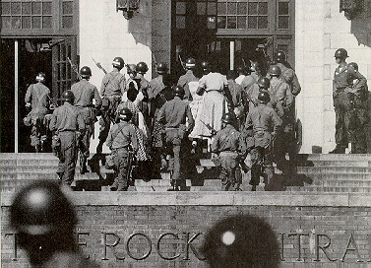

In 17 Southern and border states, 147 school districts were ready to integrate their facilities for the first time. At most places, everything went well.

But then there was Alabama—and the trouble that flared there last week diverted much of the nation's attention from the civil rights progress achieved elsewhere.

Alabama's Democratic Governor George Wallace was having none of such relatively temperate talk. On Monday, when 13 Negro children were supposed to show up for enrollment in a Tuskegee high school, Wallace sent more than 100 state troopers into the town. From Mayor Howard Rutherford on down, Tuskegee officials were enraged. But the troopers surrounded the school, turned away all pupils and teachers trying to enter, and passed around copies of Wallace's "Executive Order No.9" —which declared that the school was being shut down in order to "preserve the peace and maintain domestic tranquility."

When the morning for integration came, Wallace's troopers stayed in their hotel rooms—while two Negro boys enrolled in Graymont Elementary School. Protecting them were Birmingham's city policemen. A group of about 100 whites stood outside the school, jeered at the Negro boys, even tried to rush the police lines. The cops knocked a few on the head with their billy clubs, and the demonstrators dispersed.

Police Chief Chris Spurlock: "This is a shameful thing."

A federal judge in Alabama ordered Wallace to show cause why he should not be enjoined from interfering further with the desegregation of Birmingham schools. Similar action was almost certain to follow in Huntsville, Tuskegee and Mobile. But at week's end Governor Wallace could still boast to the press: "I want you to realize that there is not a single integrated school in the state of Alabama yet."

<http://www.time.com/time/magazine/article/0,9171,896931-1,00.html#ixzz0tgRbr3JO>

*Q. What was the purpose of Governor Wallace’s “Executive Order No.9”*

|  |
| --- |
|  |
| **4. Elizabeth Eckford is taunted by members of the crowd after being denied entry into Central High School, September 4, 1957.** |

*Q. Why would the police chief say, “This is a shameful thing”, in response to the acts committed once integration began?*

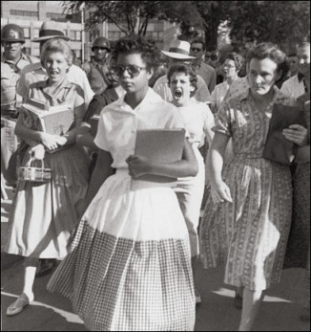

*Q. What conflicts do you see in this picture?*