Picture 1

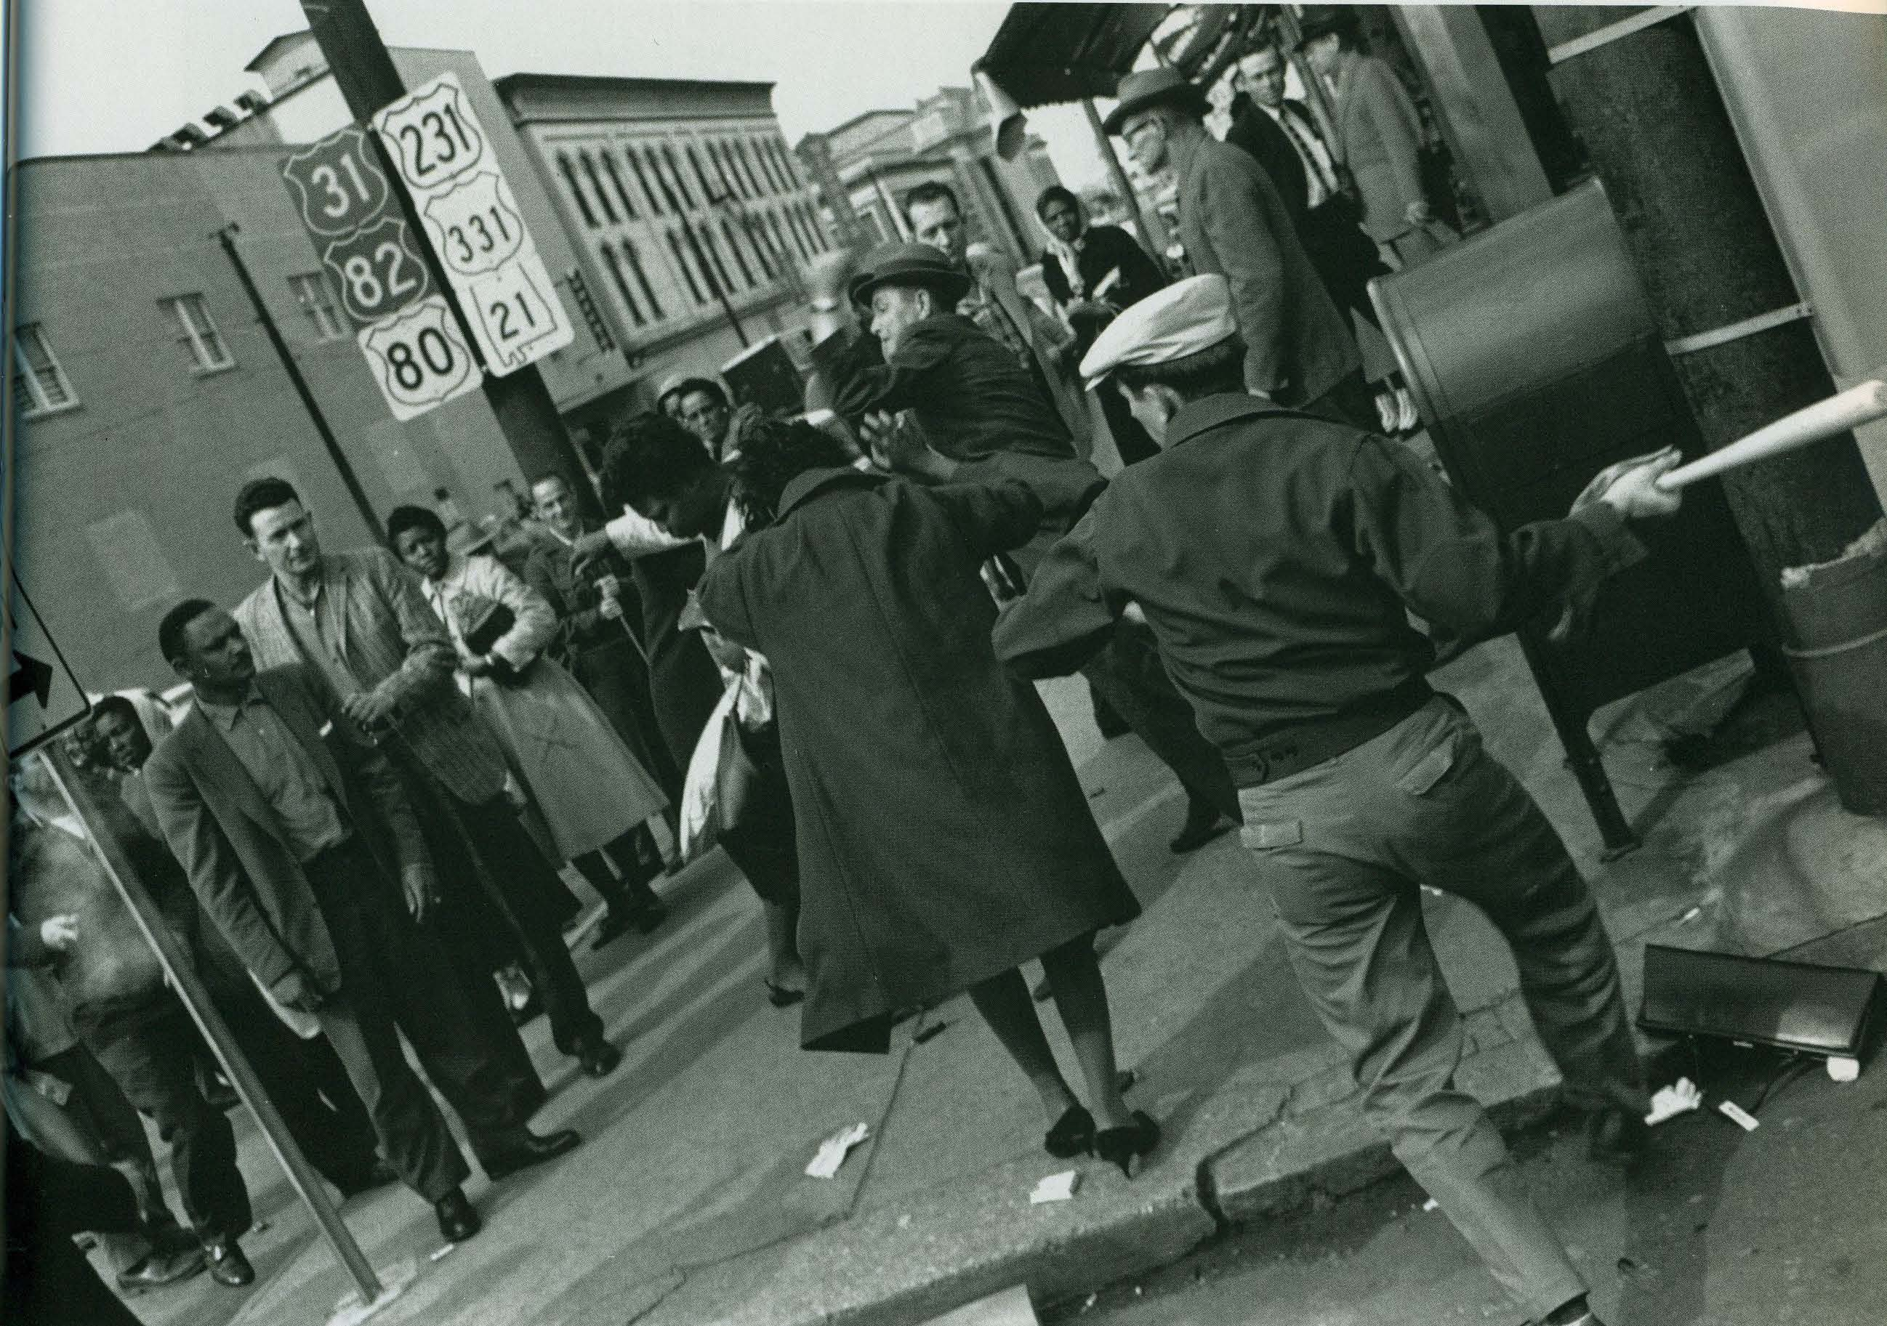
Kasher, S. (1996). The civil rights movement a photographic history, 1954 – 68. New York: Abbeville Press, pp 83.

Questions to consider:
- Describe what you see in the picture.
- What is the man in the right hand corner of the picture doing? Why do you think so?
- What do you think the woman in the middle of the picture is doing? Why do you think so?
- What are the people on the street doing? Why do you think so?
- Why do you think no one appears to be helping the lady in the middle of the picture?
- How would you have reacted if you had been the lady? Why?

Picture 2

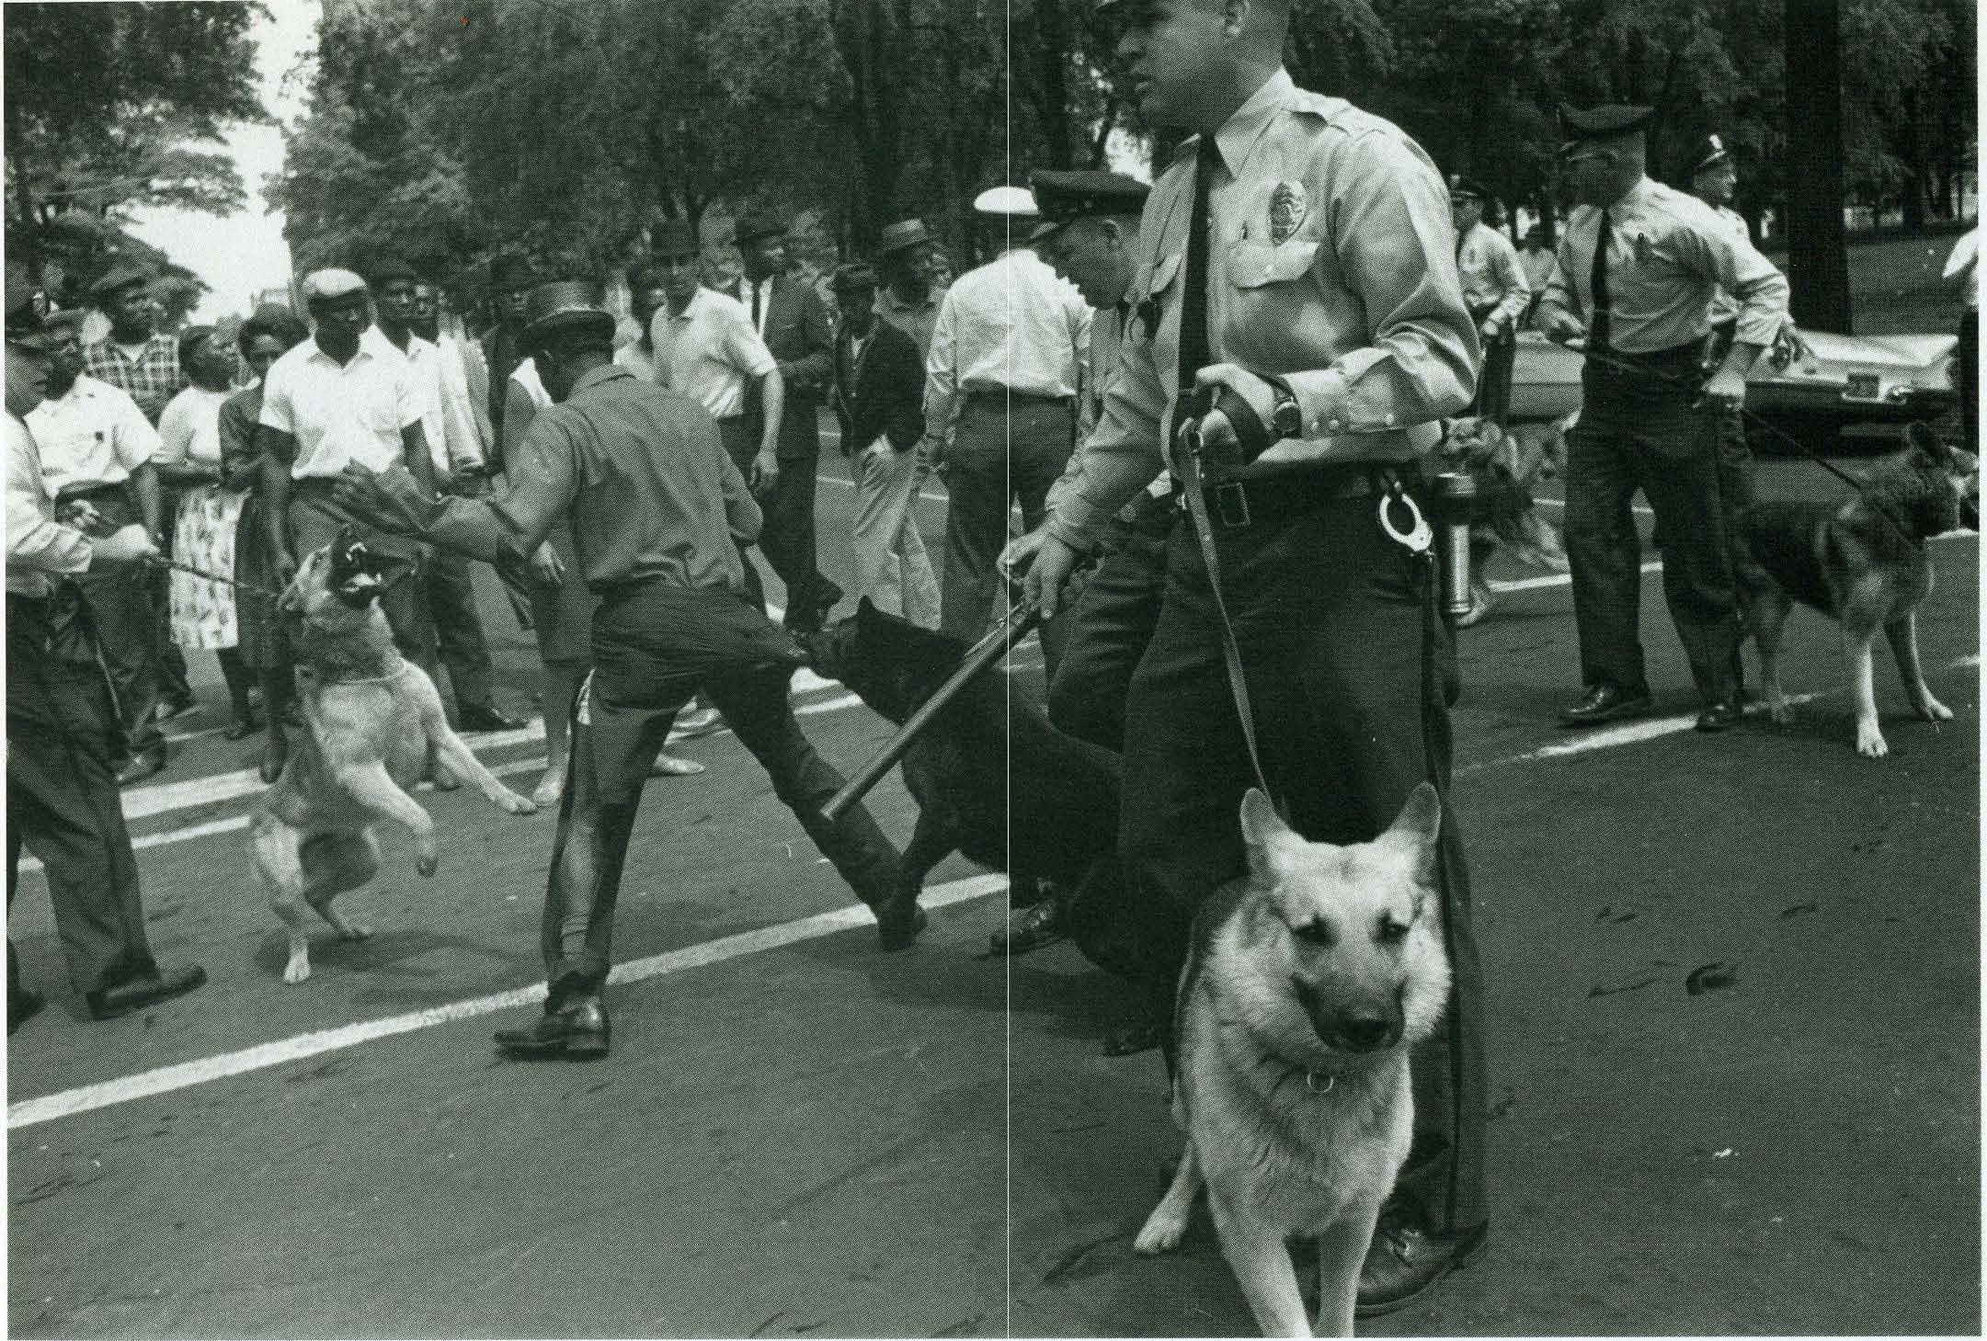
Kasher, S. (1996). The civil rights movement a photographic history, 1954 – 68. New York: Abbeville Press, pp 104.

Questions to consider:
- Describe what you see in the picture.
- What are the police officers and their dogs doing? Why do you think so?
- What are the people on the street doing? Why do you think so?
- What is happening to the African-American man in the picture who has his back to us?
- Why do you think the police dog is allowed to attack this man?
- Why do you think no one is trying to help this man?
- How do you think this man reacted after the picture was taken? Why do you think so?
- How do you think the photograph felt when taking this picture?
- How might you react if you had been this man?

Picture 3

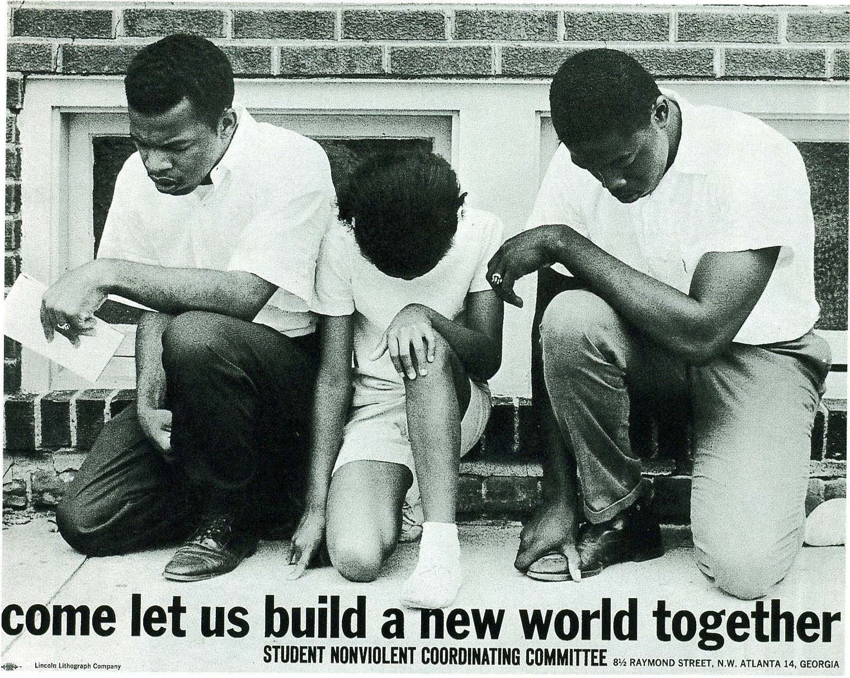
Lyon, D. (1992). Memories of the southern civil rights movement. Chapel Hill: The University of North Carolina Press, pp. 26.

Questions to consider:
- Describe what you see in the picture.
- Why do you think the people in this picture are kneeling?
- What do you think the message, “come let us build a new world together” means?
- How do you think the people in this photograph would suggest we would “build a new world”?
- What do you think this new world would look like?

