School Board Meeting: Black Parents Favoring School Desegregation Resource Packet

1. *a black father explaining why he was part of the suit in Brown v. Board, 1954.*

“It wasn’t to cause any insinuations that our teachers are not capable of teaching our children, because they are supreme, extremely intelligent, and are capable of teaching my kids or white or black kids. But my point was that not only I and my children are craving light; the entire colored race is craving light. And the only way to reach light is to start our children together in their infancy and they come up together.”

Why do you think black parents felt there children would have more “light” if they attended white schools, rather than the separate black schools?

If the black parent above says the teachers in the black schools were good, why would he want his students to go to the white school?

Why do you think the parents felt white and black students should “come up together?”

2. *citation needed (Eloise Greenfield?)*

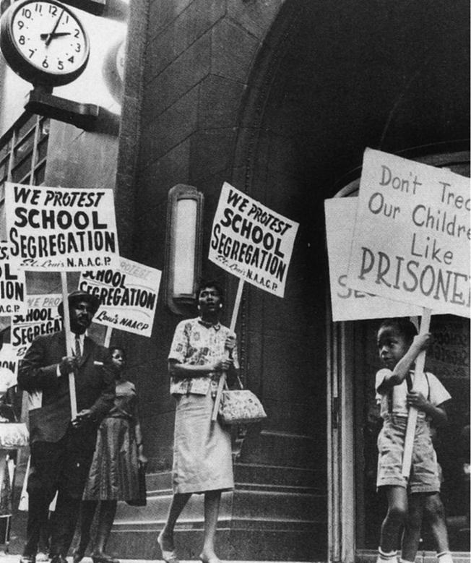

3. **excerpt from Dr. Martin Luther King, Jr.’s *“I have a dream”* speech. Washington, D.C., August 28, 1963 during the March on Washington for Jobs and Freedom.**

I have a dream that my four little children will one day live in a nation where they will not be judged by the color of their skin but by the content of their character.

I have a dream today.

I have a dream that one day, down in Alabama, with its vicious racists, with its governor having his lips dripping with the words of (defying integration efforts); one day right there in Alabama, little black boys and black girls will be able to join hands with little white boys and white girls as sisters and brothers.

*Q. How would Dr. King’s dream be realized if black and white children went to school together?*

*Q. Why does Dr. King say children are going to separate schools? Why does he feel that is wrong?*

4. Black schools received “left overs” from white schools: sports uniforms, books, lab equipment, maps, etc. The buildings were not repaired or taken care of at the same level as white schools. Often black children had to share books as there were not enough for every student.

**Henrietta Snipes, a student in Opelika, Alabama**

What she saw when she got to Miriam Brown Elementary (white school) in September was a different world than the one she knew at Jeter (black school). “There were things when I transferred over that I had never seen,” she recalled; “you’d be surprised, something as simple as a nice globe or something like that. We didn’t have any of those things, audio-visual, those kind of Title 1 things that were being state and federally funded that we should have had.” “What we had in the black schools,” she explained, “we always had leftovers.”

**Bobby Floyd, student in Opelika, Alabama reported,** “when we integrated, the problem of “hand-me-downs” left. We had workbooks per child, individual books, art supplies; everybody got what they needed.”

*Q. What do these quotes indicate about the learning opportunities black students had in segregated schools?*

*Q. Why would having updated supplies and books matter to a quality education?*

5. **Segregated public schools for white and black children. Macon County, Georgia, 1936**

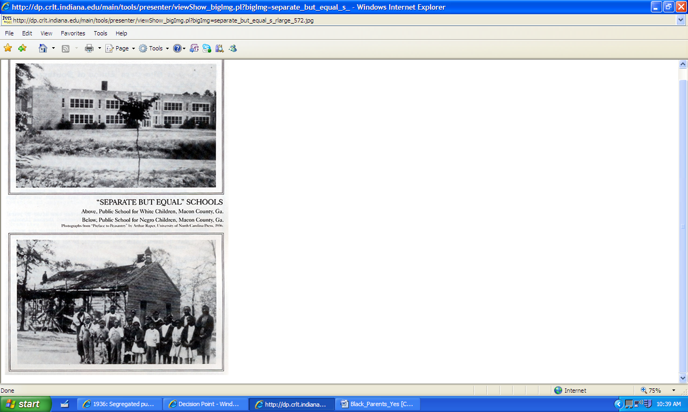

*Q. What do these pictures indicate about the facilities of white and black schools?*

*Q. What do they indicate about the notion of “separate but equal?”*

7. **Racially Integrated Classroom, Berlin Township, New Jersey. 1952**

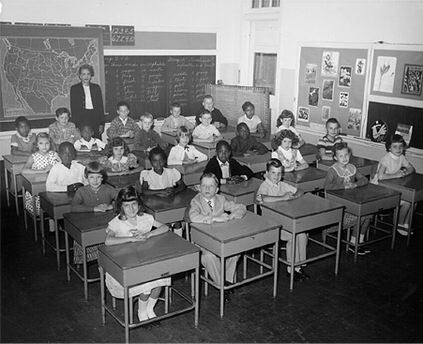

*Q. What might this picture indicate about integrating schools?*