**School Board Meeting: Black Activists Opposing Integration**

**1. Stokley Carmichael on “Black Power” from *What We Want* (1966)**

“Integration, moreover, speaks to the problem of blackness in a despicable way. As a goal, it has been based on complete acceptance of the fact that *in order to have* a decent house or education, blacks must move into a white neighborhood or send their children to a white school. This reinforces, among both black and white, the idea that “white” is automatically better and “black” is by definition inferior. This is why integration is a subterfuge (trick) for the maintenance of white supremacy. It allows the nation to focus on a handful of Southern children who get into white schools, at great price, and to ignore the 94 percent who are left behind in unimproved all-black schools.”

Such situations will not change until black people have power—to control their own school boards, in this case.

*Q. What argument for segregation does Stokley Carmichael make in the above statement?*

**2. Adam Faircloth *Teaching Equality: Black Schools in the Age of Jim Crow* (2001) p. 62-65**

Black teachers had particular worries, because integration -as whites were quick to point out, would involve shutting down black schools, phasing out black colleges, and abolishing thousands of jobs. The fact is that school integration divided black teachers because it divided the black community at large…”What exactly was wrong with the old , black public schools that for years served their constituencies (community) so well despite the deprivations and the isolation of segregation?”

*Q. What issues are facing the black community with the enforcement of integration?*

**3. Excerpt from Stuart Buck interview with a student and teacher in Charlotte, NC: *Acting White* June 2010**

"An institution was being closed, and not necessarily for progress, but because of integration… Well, it was heartbreaking. It really was. It really was.” Another person said, “We thought that it was the utmost in betrayal.” A former teacher from Second Ward later said, “I still kept contact with those kids from Second Ward, and they would call and sometimes cry.”

*Q. What has occurred that is heartbreaking?*

*Q. Why is this situation heartbreaking?*

**4. Henrietta Snipes was a black resident of Opelika, AL and recalls this after Darden High School (the black high school) was closed:**

They totally shut the black high school down; it was just gone. We totally lost everything. For females…we lost cheerleading, we lost majorettes. So, people felt like we had to sort of take a back seat to everything. It was not a good time for blacks, because most of us felt like we were forced to change, and we’re the ones that are forced to give up everything. It took a lot of adjusting and a lot of praying to get through.”

*Q. Why does Henrietta feel the way schools were integrated was unfair to black students*

*and communities?*

**5. Birdie Petersen, of Opelika, AL, said, “**“What we wanted was that the money that was invested in one school should have been invested in all schools regardless of race.”

*Q. What is the solution proposed in this quote for equal education opportunities?*

**6. Malcolm X's position on Black Integration into the White culture of America. Teacher’s Domain: ABC News Archival Footage (1963)**

Malcolm X advocated Black Nationalism - an ideology that encourages African Americans to live separate from white society. He was critical of the desire of many civil rights leaders for racial integration, arguing that whites would never accept African Americans as equals. He also believed that integration represented a rejection of black culture and an adoption of white values and white culture. "The white man has brainwashed the so-called Negro to the point of believing white supremacy so much so that today some Negroes think that they are not making progress or that they don't have anything unless they have a white man's neighborhood, a seat in the white man's school, or a position in a white man's job."

Malcolm X encouraged African Americans to look inward and embrace their own culture: "[The] lack of knowledge concerning our original culture . . . has made the black man in America have this inferiority complex." By learning about their history and heritage, he believed, African Americans strengthened black communities and institutions independent of the white world

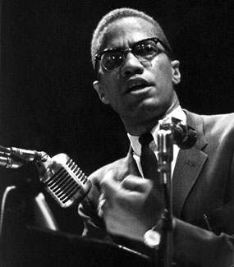

*Q. What did Malcolm X promote or support?*

*Q. What misconception does Malcolm X say African Americans have about integration?*

**5. Protest to integration in Hyde County, NC**

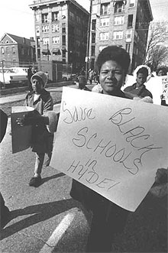

*Q.What is this woman protesting for?*

**6. Oakland Community School**

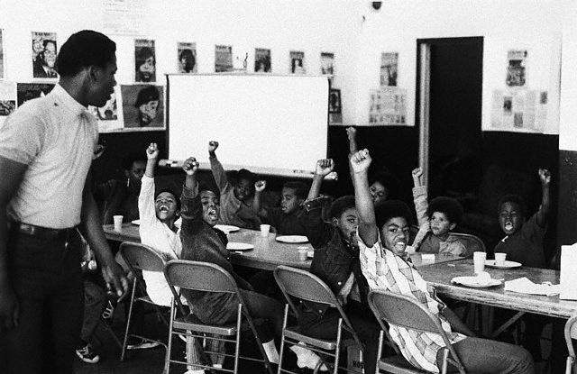

*Q.Do these students look underprivilaged?*

*Q. How does this picture support the views of Malcolm X and other black separatists?*