**School Board Meeting on Integration: Black Activists Favoring Integration**

**Legal Arguments supporting School Desegregation**

**The following documents are all referring to legal arguments for the integration of schools.**

I. Declaration of Independence, 1776.

“We hold these truths to be self-evident, that all men are created equal, that they are endowed by their Creator with certain unalienable Rights, that among these are Life, Liberty and the pursuit of Happiness.”

II. 14th Amendment to the Constitution, ratified in 1868.

“No state shall make or enforce any law which shall abridge the privileges or immunities of citizens of the United States; nor shall any state deprive any person of life, liberty, or property, without due process of law; nor deny to any person within its jurisdiction the equal protection of the laws.”

**Q: Why are each of these two documents important in writing and enforcing laws?**

**Q: Find three phrases in the two documents above that explain the government’s responsibility in its treatment of citizens?**

III. Justice John Marshall Harlan, dissented from the majority opinion in *Plessy v. Fergusson* in 1896 which said separate is equal. Harlan disagreed with the court’s decision and his dissent was used in the *Brown* decision, which found “separate but equal” was unconstitutional.

“Our Constitution is color-blind, and neither knows nor tolerates classes among citizens.”

**Q: What does Justice Harlan mean by “color-blind?”**

IV. Kenneth and Mamie Clark were psychologists called as experts to testify in the *Brown v. Board of Education* case.

In the "doll test," psychologists Kenneth and Mamie Clark used four plastic, diaper-clad dolls, identical except for color. They showed the dolls to black children between the ages of three and seven and asked them questions to determine racial perception and preference. Almost all of the children readily identified the race of the dolls. However, when asked which they preferred, the majority selected the white doll and attributed positive characteristics to it. The Clarks also gave the children outline drawings of a boy and girl and asked them to color the figures the same color as themselves. Many of the children with dark complexions colored the figures with a white or yellow crayon. The Clarks concluded that "prejudice, discrimination, and segregation" caused black children to develop a sense of inferiority and self-hatred.

* With and Even Hand” LOC web site: <http://www.loc.gov/exhibits/brown/brown-brown.html>

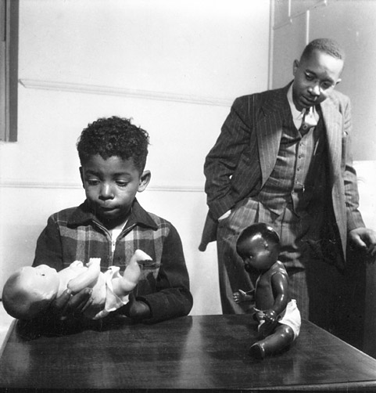

**Q: Which doll did most of the black children in the doll study prefer? Why?**

**Q: Explain your view point on the “doll test,” pertaining to being inferior to others.**

V. Chief Justice Earl Warren wrote the majority of the opinion for the Supreme Court’s *Brown v. Board of Education* decision in 1954 saying “separate but equal” is unconstitutional.

“To separate them from others of similar age and qualifications solely because of their race generates a feeling of inferiority as to their status in the community that may affect their hearts and minds in a way unlikely ever to be undone.”

"Segregation of white and colored children in public schools has a [negative] effect upon the colored children. The impact is greater when it has the [force] of the law; for the policy of separating the races is usually interpreted as [assuming] the inferiority of the negro group. A sense of inferiority affects the motivation of a child to learn. Segregation with the [force] of law, therefore, has a tendency to [slow] the educational and mental development of negro children and to deprive them of some of the benefits they would receive in a racial[ly] integrated school system."

“We conclude that in the field of public education the doctrine of "separate but equal" has no place. Separate educational facilities are inherently unequal. Therefore, we hold that the plaintiffs and others similarly situated for whom the actions have been brought are, by reason of the segregation complained of, deprived of the equal protection of the laws guaranteed by the Fourteenth Amendment.”

inherently: by definition, by their nature

plaintiff: people who wanted integrated schools

**Q: How did Chief Justice Warren feel that segregated schools would effect children?**

**Q: Why did he think “separate but equal” schools weren’t working?**

This photograph was taken at a segregated black school in Gee’s Bend, Alabama:

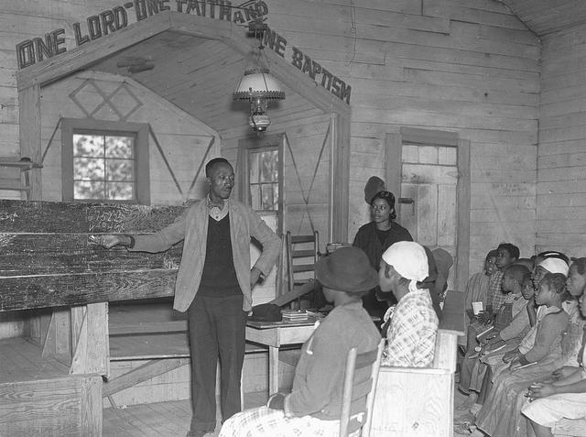

**Q: Does this building look like it has another purpose other than being a school?**

**Q: Do the students look like they are all the same age, or grade?**

**Q: What is the teacher using as a blackboard?**

**Q: This classroom is clearly “separate,” but, do you think it is “equal” to the whites-only schools?**

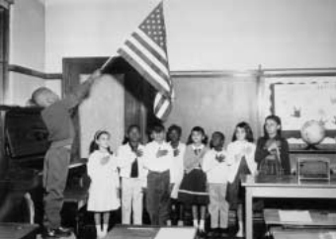

VI. Supremacy clause of the U.S. Constitution (found in Article VI of the Consitution)

This Constitution, and the Laws of the United States which shall be made in Pursuance thereof; and all Treaties made, or which shall be made, under the Authority of the United States, shall be the supreme Law of the Land; and the Judges in every State shall be bound thereby, any Thing in the Constitution or Laws of any State to the Contrary notwithstanding.

[The U.S. Constitution, and the laws of the U.S., and all treaties made under the authority of the U.S., shall be the Supreme Law of the Land; and judges in every state have to follow those laws, and anything found in the Constitution or Laws of any state must follow those laws.]

**Q: Legally, which is more important… state laws, or federal laws?**

**Q: Since the Brown vs. Board of Education ruling was in a federal court, would it be more important than state laws? (according to the Supremacy Clause in the U.S. Constitution)**

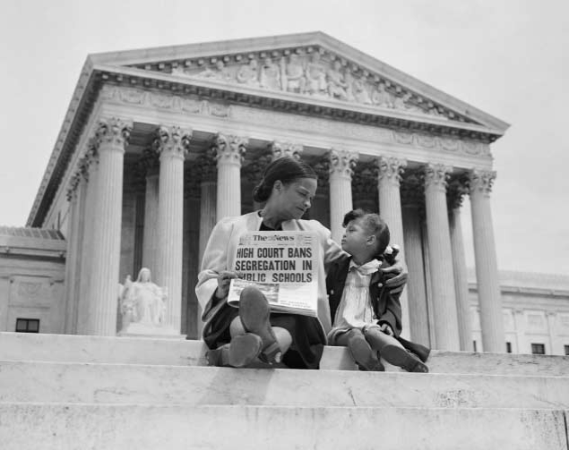

**Q**: **What does the headline of the newspaper refer to?**

**Q: Where do you think this mother and child are sitting?**