Your Situation

You are an award winning script writer for your works such as: *Independence Day*, *The* *Patriot*, *The* *Notebook*, and *The* *Hangover*. You have received an invention from Paramount pictures to enter the Andrew Jackson Film Festival held at the Hermitage in Nashville, Tennessee. The funding for your film will come from one of six organizations whose goal is to educate the public on the “truth” behind Andrew Jackson and his policies. In order to receive funding, you must accurately portray the views of the organization that you have been assigned. Your film is one of many movies that have been chosen to produce a movie for this festival. If your film wins, Paramount Pictures will release your movie in 6,000 screens nation wide, as well as on 47 IMAX screens; you will also be given royalties right to action figures, lunchbox paraphernalia, and a PS3/XBOX360 video game.

The direction of the film is entirely in your hands, although you must represent the organization that is financing your project, or risk losing all funding (you fail the project). The film festival has requested that your script be centered on the following question:

**CQ: Were the actions of the Jackson Administration in the best interest of all peoples in America?**

Each organization will present you with perspective sheet informing you of their position on Jackson and his policies.

Andrew Jackson Film Festival

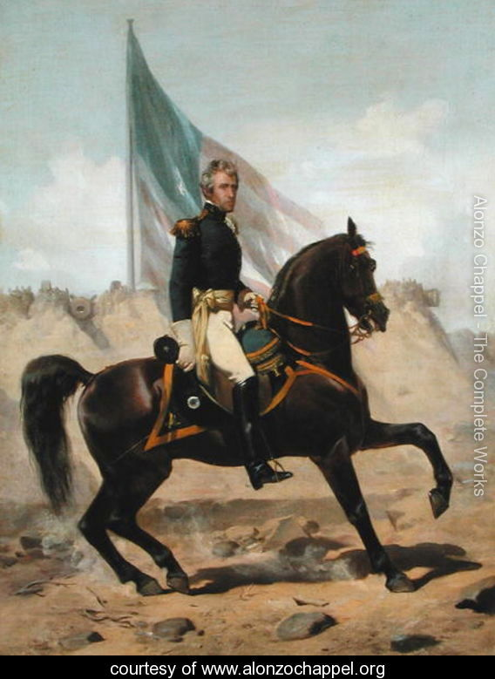

Welcome to the Andrew Jackson

Film Festival

**List of Organizations**

* ***The National Organization of Removed Indians***- This organization represents the disfranchised tribes of the old southeast. They are descendents of the 5 civilized tribes (the Chickasaw, Choctaw, Cherokee, Creek and Seminole) who were removed from their homelands by the Indian Removal Act of 1830.
* ***The Southern Plantation Society***- This organization was created in 1878, and is composed of descendants of plantation owners in the south. This group was predominately wealthy white southerners who made their fortune using slave labor to grow such crops as cotton, rice, and tobacco.
* ***Independent Farmers of America*** - This organization represents the descendants of Yeomen farmers from the South. In contrast to the Southern Plantation Society, this group was made up of poor white farmers, many of which could not afford the land to farm on, let alone slave labor.
* ***The Coonskin-Cap Society***- This organization is composed of descendants from the original pioneers of the early 1800s. These people wished to rid the west of the dangers of savage inhabitance. Many of these people made their money from selling animal skins to traders from eastern cities.
* ***Northeastern Manufacturers’ Association***- This organization represents the descendants of business leaders from the northeast. Many of the business leaders lost considerable amount of power after the year 1832, due to the collapse of the National Bank.
* ***Jacksonian Democratic Party***- This political party basis it’s ideology on the policies of Andrew Jackson. This group is made up of “common men” who strive for more participation in the government, and protection from a stronger Executive Branch.
* ***The Whig Party****-* This political party opposes the views and goals of the Jacksonian Democrats. They call for the passing of the American System to help strengthen the economy, thus strengthening the country.

**Group Responsibilities**

Each group is responsible for completing the following during this Culminating Project:

* + - Movie poster- visual representation of your group’s film
    - Movie Trailer- short representation of your group’s film
    - PowerPoint presentation including all of the following:
      * Describing their perspective
      * Describing their film
      * Movie poster (can be on poster or in photo shop embedded in PP)
      * Trailer
      * Group’s answer to the central question

**Individual Responsibilities**

Each individual is responsible for completing the following during this Culminating Project:

* An individual paper answering the question:

**CQ: Were the actions of the Jackson Administration in the best interest of all peoples in America?**

* This paper will be written from your own perspective, not the perspective that your group represented. The paper must be written following the Culminating Paper Guidelines (see sheet)

**Movie Poster Directions**

**Directions**: Students have two options: Create a movie poster on a poster board using colored pencils, markers, and such. OR Create a movie poster using Photoshop or a comparable computer program and include this image in the PowerPoint presentation. Groups must choose the most appropriate option based on computer capabilities and knowledge within the group. Groups that do not include members who already are proficient in using Photoshop or a similar program and have access to it should think about making their movie poster on poster-board.

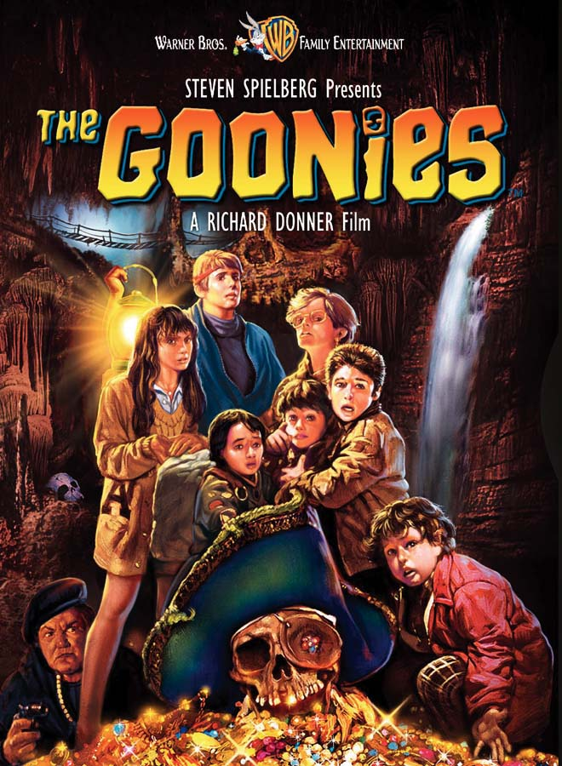

**Must Include**

Title

-The title should reflect the point of view of your assigned perspective. The title cannot include SFI! You must be creative here!

Visual Representation

-A minimum of 5 of the listed SFI for your topic must be represented visually on the movie cover. Be sure to reflect your perspective on the issues being presented. Also be sure to address whether your movie will depict Jackson in a positive or negative light in the symbolism shown in your poster. Ultimately the poster should preview the content and theme (comedy, drama, action…) of the movie for the audience.

**Movie Trailer guidelines**

When working on the trailer for your movie, it is important that the following elements are present:

* **Setting**- The time and location in which a story takes place is called the setting.  For some stories the setting is very important, while for others it is not.  There are several aspects of a story's setting to consider when examining how setting contributes to a story.
  + Place- geographical location. Where is the action of the story taking place?
  + Time- When is the story taking place? (historical period, time of day, year, etc.)
  + Social Conditions- What is the daily life of the characters like? Does the story contain local colour (writing that focuses on the speech, dress, mannerisms, customs, etc. of a particular place)?
  + Mood or Atmosphere- What feeling is created at the beginning of the story? It is bright and cheerful or dark and frightening?
* **Rising Action**- This is where the events in the story become complicated and the conflict in the story is revealed (events between the introduction and climax).
* **Conflict**- Conflict is essential to plot. Without conflict there is no plot. It is the opposition of forces which ties one incident to another and makes the plot move. Conflict is not merely limited to open arguments, rather it is any form of opposition that faces the main character. Within a movie there may be only one central struggle, or there may be one dominant struggle with many minor ones.
* **Climax**- This is the highest point of interest and the turning point of the story. The reader wonders what will happen next; will the conflict be resolved or not?
* **Resolution**- This is the final outcome or untangling of events in the story.

These elements can be found in DRC #2 in the “Movie Plot” box. This box should have been completed earlier, and checked off by the teacher, making the movie trailer easier to create. Remember, your film trailer MUST have 10 pieces of SFI (specific factual information), and they must be easily visible.

Make sure that Andrew Jackson is a character in your movie trailer. Group members may play dual roles if needed.

Each group member, regardless of role, must take a part in the creation of the trailer. Failure to do so may lead to group failure, as well as individual failure.

**Andrew Jackson Film Festival**

**PowerPoint Presentation**

At the Andrew Jackson Film Festival, you will be giving a presentation on your film, and the organization that you are representing. This presentation will help build hype for your film in the hopes that it will win the Festival and receive “blockbuster” treatment by Paramount Pictures. Your PowerPoint presentation will have to represent the history, beliefs, and answer the CQ from the point of view of the organization that is funding your film. When creating the presentation, think about the following issues:

1. Who is the group that is funding your film? What is their history?
2. What are the basic views of the organization?
3. Clearly present your client’s opinion on whether or not the Jackson Administration’s were justified in promoting fairness for all societies in America.

Your presentation will need to include the film title, group members/roles, CQ, movie poster, movie trailer, and your organization’s answer to the CQ. Your presentation needs to be no longer than 7 slides. The following is a break down of what needs to go on each slide.

**First Slide**: This is your title slide. On this slide you need to include the title of your Film, your funding organization, all group members’ names and roles, and the central question.

**Second Slide**: Briefly describe your group’s beliefs. Use pictures to represent your organization.

**Third Slide**: If you have created your movie poster using a computer, you will put it on this slide. If you have created your movie poster on a poster board you will present your poster at this time.

**Forth Slide**: Your movie trailer goes on this slide.

**Fifth Slide**: On this slide you need to answer the central question according to your group’s perspective. Keep in mind this is NOT your opinion as an individual, but as a person in the group that you are a part of (example: Coon-Skin Cap Society).