**Is the SC the best governmental institution to decide issues of Civil Rights?**

**Yes: The 14th amendment to the US Constitution is intended to protect the rights of the minority when the majority in a state are violating them.**

***Brown v. Board of Education*, Supreme Court of the US, 1954**

<http://www.streetlaw.org/en/Page/503/Classifying_Arguments_for_Each_Side_of_the_Case>

* The Equal Protection Clause of the Fourteenth Amendment of the Constitution states:
  + No State shall . . . deny to any person within its jurisdiction[1] the equal protection of the laws."
* The Fourteenth Amendment precludes[2] a state from imposing distinctions based upon race. Racial segregation in public schools reduces the benefits of public education to one group solely on the basis of race and is unconstitutional.
* Psychological studies have shown that segregation has negative effects on black children. By segregating white students from black students, a badge of inferiority[3] is placed on the black students, a system of separation beyond school is perpetuated[4], and the unequal benefits accorded[5] to white students as a result of their informal contacts with one another is reinforced. The U.S. District Court found that segregation did have negative effects on black children.
* *A black father explaining why he was part of the suit in Brown v. Board, 1954.* 
  + “It wasn’t to cause any insinuations that our teachers are not capable of teaching our children, because they are supreme, extremely intelligent, and are capable of teaching my kids or white or black kids. But my point was that not only I and my children are craving light; the entire colored race is craving light. And the only way to reach light is to start our children together in their infancy and they come up together.”

***Sweatt v. Painter*, Supreme Court of the US, 1950**

http://www.streetlaw.org/en/Page/503/Classifying_Arguments_for_Each_Side_of_the_Case

In this case Herman Sweatt was rejected from the University of Texas Law School because he was black. He sued school officials alleging a violation of his Fourteenth Amendment rights. The Court examined the educational opportunities at the University of Texas Law School and a new law school at the Texas State University for Negroes and determined that the facilities, curricula, faculty and other tangible factors were not equal. Furthermore, the justices argued that other factors such as the reputation of the faculty and position and influence of the alumni could not be equalized. They therefore ruled in favor of Sweatt.

***Briggs v. Elliot*, Federal District Court: Clarendon County, S. C., 1951 (became part of *Brown v. Board* cases)**

*Testimony of Harold J. McNally, associate professor of education, Columbia Univ.*  
5-29-51, Briggs v. Elliot desegregation case

* If one considers the purpose of public school education in a democracy, it is clear that here is the only place where a child encounters others from every economic level; here alone they come together to know one another; and one purpose of education is to develop respect for the historic concept of equality.
* . . . So far as Negroes are concerned, segregation itself implies a difference, a stigma, and relegates the segregated group more or less to second class.

Opelika City Schools

A Meaningful Reality: The Integration of the Opelika, Alabama City School System, 1965-1972, Thesis by Joseph Mark Bagley, Auburn University, 2007

* **Henrietta Snipes, a student in Opelika, Alabama**
  + What she saw when she got to Miriam Brown Elementary (white school) in September was a different world than the one she knew at Jeter (black school). “There were things when I transferred over that I had never seen,” she recalled; “you’d be surprised, something as simple as a nice globe or something like that. We didn’t have any of those things, audio-visual, those kind of Title 1 things that were being state and federally funded that we should have had.” “What we had in the black schools,” she explained, “we always had leftovers.”
* **Bobby Floyd, student in Opelika, Alabama** 
  + “when we integrated, the problem of “hand-me-downs” left. We had workbooks per child, individual books, art supplies; everybody got what they needed.”

Separate was not equal: Pictures of a white school and a black school in Macon, County, GA 1936.

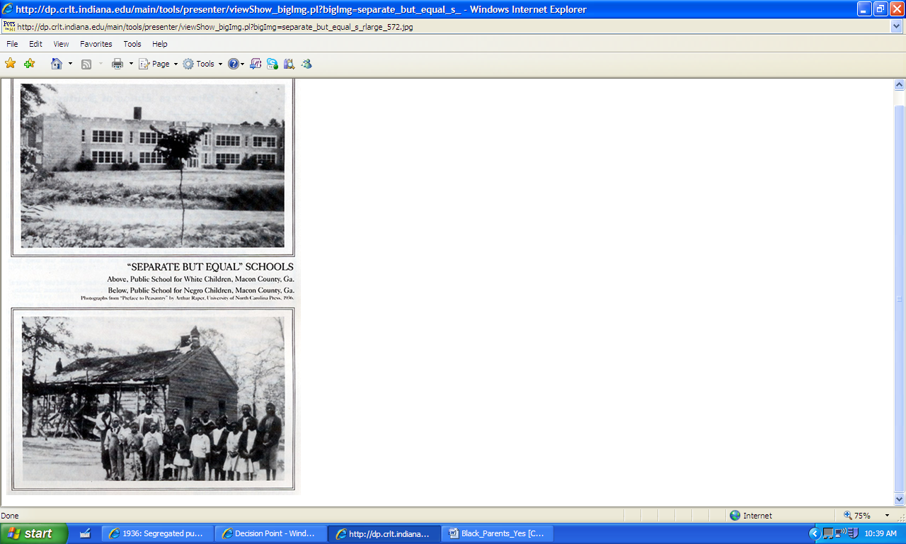

**Brown in Fayetteville: Peaceful Southern School Desegregation in 1954**

Andrew Brill, The Arkansas Historical Quarterly, VOL. LXV, NO. 4, Winter 2006, pp. 347-350

The state’s second-largest newspaper, the Arkansas Democrat, ran an article in September entitled “Fayetteville School Plan Unopposed,” a headline that contained surprisingly little exaggeration. The board received some one hundred letters regarding integration during the summer, and less than fifteen percent opposed the decision. No Fayetteville residents ever attended a school board meeting to protest the decision, and no focused opposition emerged in town. Board member William C. Morton, Jr., who owned an insurance agency, recalled that he never had any business problems because of the board’s decision and, to his knowledge, neither did any of the other board members. In contrast to other southern communities, where school transfers sometimes reached epidemic proportions, no Fayetteville students transferred to private schools rather than face integration. Most local white ministers and churches strongly supported the board’s decision, and many Fayetteville High student leaders were active in youth groups at these churches. White youths from the local Methodist, Presbyterian, Episcopal, and Disciples of Christ churches even took it upon themselves to meet with Fayetteville blacks during the summer.

When faculty and students became aware of the board’s decision, both groups began preparing for the year. It was understood that Louise Bell, the Fayetteville principal since 1945, would not tolerate any outspoken opposition from the few teachers who opposed desegregation. Bell worked with Minnie Dawkins, the principal of Lincoln School[6], to make the transition smooth for both the African-American and white students. Bell worked with student leaders and sponsored school tours for the African-American students, while Dawkins met with the black students and their parents. The two women also discussed the academic side of integration, recognizing the black students’ academic strengths and weaknesses and planning their courses of study accordingly. Vandergriff met with Bell to discuss the details of integrating athletics, and the faculty met at the beginning of the school year to consider the logistics of desegregation.

Some Fayetteville High students took it upon themselves to ensure smooth desegregation. Two prominent student organizations, the Twenty- Six Club and Student Council, acted as though integration was non-controversial. The Twenty-Six Club, for example, provided a “new student orientation,” grouping the seven blacks with incoming white students and avoiding specific reference to the African-American students so as not to draw attention to them. Student leaders also lobbied the school board to integrate all aspects of the school, including athletics. White church youth groups met with similar groups from black churches to promote communication between the races. One white student later said that these relationships, formed within the boundaries of religious activities, “helped destroy the feeling that Negroes would not be welcome in the high school.” Parents did not become overly involved in the desegregation process, but adults did provide support and guidance at times. Throughout the summer, white churches worked with their youth to prepare them to accept integration and their new African-American peers.

On September 10, 1954, after a summer of preparation, five black students—Mary Mae Blackburn, Laverne Cook, Elnora Lackey, Roberta Lackey, and Virginia Lee Smith—entered Fayetteville High School along with the rest of the sophomore class to register for classes. When classes began the following Monday, juniors Preston Lackey and Peggy Taylor brought the total to seven black students. Five of these seven students were related—the three Lackeys were siblings and Blackburn and Smith were their cousins. In most ways, the day seemed just the same as the first day of school any other year. The Arkansas Democrat reported, “The fact that they were breaking one of Dixie’s oldest and most prized traditions was accepted by both Negro and white students with an air of indifference.”

**Majority Rule is a joke – blacks couldn’t vote:**

Columbia Law School Professor, Greenburg

<https://www.law.columbia.edu/focusareas/brownvboard/bvbopposing>

As to state legislatures, or Congress, that's a bad joke. Blacks couldn't vote. At the time of the 1965 Voting Rights Act, black voting in the 100 counties with the largest black populations was at most 8 percent, in many places about 2 percent…

1. Area of legal responsibility and authority
2. prevent from happening, make impossible
3. belief of being less valuable or important
4. continued
5. given
6. Lincoln School was the former all-black junior high school. Fayetteville had too few black students to have it’s own black high school so it paid for black high school students to attend and live in neighboring towns. They spent three times as much on black students as on whites, but there was a very small number in total.